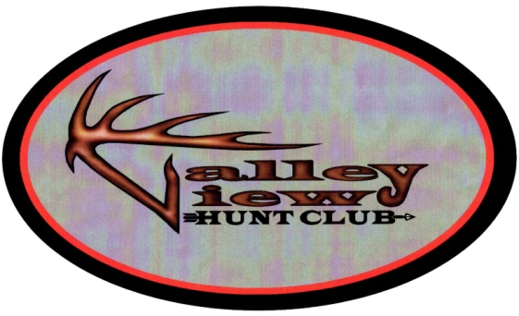
2015 Permission for Hunting, Fishing or Trapping

Permission is hereby granted to the undersigned Valley View Hunt Club (VVHC) member:
For hunting/fishing/trapping on land by the undersigned Secretary of the VVHC for the dates listed and according to the conditions stated on this permit.

In accepting this permit, I agree to assume and release the landowner and the Valley View Hunt Club from any or all liability for personal injuries, property damage, or for the loss of life or property resulting from, or in any way connected with the issuance of this permit.

Hunting/Fishing/Trapping Permission Period:
March 1,2015 - Feb 29,2016

Member Name _________________________________________________

Signature______________________________________________________________

Hunting/Fishing License No. ____________________________________________________

Emergency Contact Telephone (________) ________________________________________

Vehicle License No., Make, and Model: ___________________________________________

___________________________________________________________________________

Signature:

Brian Exton, Secretary VVHC
Call 216-544-8469- if any problems or questions.

Ohio Revised Code 1533.181: Exemption from liability to recreational users
(A) No owner, or lessee, or occupant of premises:
(1) Owes any duty to a recreational user to keep the premises safe for entry
or use;
(2) Extends any assurance to a recreational user, through the act of giving
permission, that the premises are safe for entry or use;
(3) Assumes responsibility for or incurs liability for any injury to
person or property caused by any act of a recreational user.
1-Landowner or Agent - 2-Hunter/Angler
DNR 8924 (R1106)
Conditions
1. To respect the rights of the property owner
2. To be careful in the handling of firearms
3. Not to damage fences, buildings, or other property
4. Not to litter the area or dump any rubbish
5. To obey all hunting laws and regulations of the Division of Wildlife
6. This free permit is only valid on the lands of the issuing landowner and
only for the days specified.
7. To abide by the hunting/Fishing rules and regulations set forth in the VVHC Manual.

